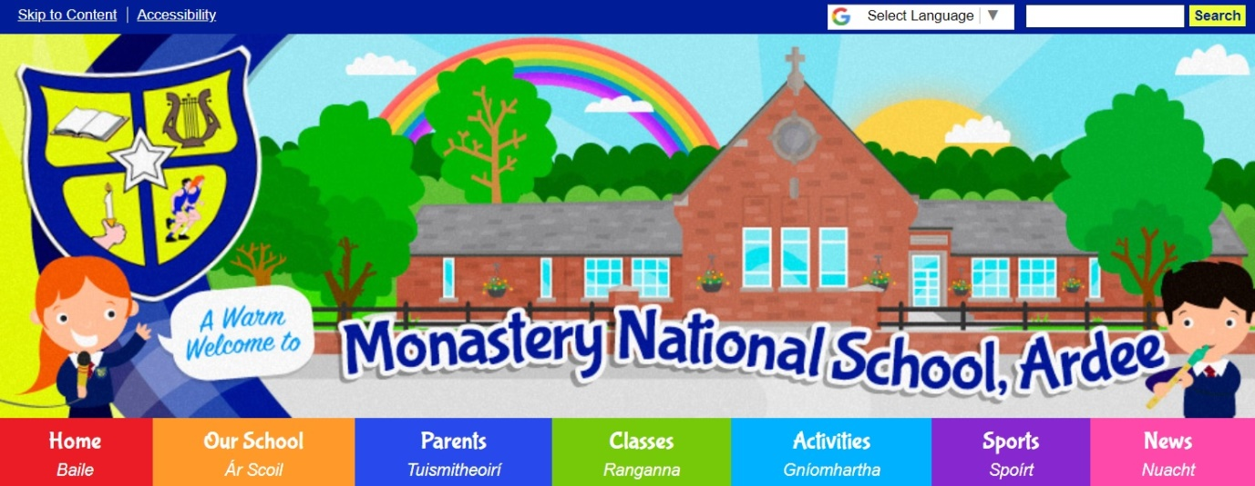
Dear Parents/Guardians, 2nd October, 2023.

First Communion and Confirmation Classes 2023/2024
The Family Masses schedule for the sacramental classes is listed below.
All the children, along with their families are requested to attend.
Parish of Ardee/ Collon
FAMILY MASSES 2023/2024
Sunday, 8th October, 2023 12noon Mass
Sunday, 12th November 2023 12noon Mass
Sunday, 10th December, 2023 12noon Mass
Sunday, 14th January, 2024 12noon Mass
Sunday, 11th February, 2024 12noon Mass
Sunday, 10th March, 2024 12 noon Mass
Sunday, 14th April, 2024 12 noon Mass
Sunday, 12th May, 2024 12 noon Mass
Sunday, 9th June, 2024 12 noon Mass
Yours sincerely,
_______________ ______________
Ms. O’Neill Master Garland
2nd class teacher 6th class teacher

